|  |  |  |  |  |
| --- | --- | --- | --- | --- |
|  |  |  | Requirements | |
|  |  |  |  |  |
|  |  |  | Project Name: | Biochemical Plate, Assay, and Result Management system |
|  |  |  |
|  |  |  |
|  | Date: | 23rd Feb 2015 |
| CSCIE-99  Project | Customer: | Peter Henstock |
|  |  |  |  |
|  |  |
|  |  |  | |
|  |  |  |  | |

Contents

1. Document Administration 3

1.1 Document Change History 3

1.2 Document Content Owners 3

1.3 Document Reviewers 4

1.4 Document Approvers 4

2. Assumptions and Constraints 5

2.1 Assumptions 5

2.2 Constraints 5

3. Scope 6

3.1 In Scope 6

3.2 Out of Scope 6

4. Proposed Functionality 7

4.1 Overview 7

5. Business (Functional) Requirements 8

5.1 Security Functional Requirements 8

5.1.1 Security Overview 8

5.1.2 Sample Screens / StoryBoard 8

5.1.3 Open Issues / Questions Security Section 10

5.2 Plate Management Requirements 11

5.2.1 Plate Management Overview 11

5.2.2 Sample Screens / Story Board 12

5.2.3 Open Issues / Questions Plate Management 13

5.3 Experiment Management Requirements 14

5.3.1 Overview 14

5.3.2 Sample Screens / Story Board 15

5.3.3 Open Issues / Questions Experiment Management 16

5.4 Results Analysis Requirements 17

5.4.1 Overview 17

5.4.2 Sample Screens / Story Boards 17

5.4.3 Open Issues / Questions Results Analysis 17

5.5 Special Feature Proposals 18

5.5.1 Overview 18

5.5.2 Interactive Visualization 18

5.5.3 Audit Trail 20

5.5.4 Four Eyes Protocol 21

5.5.5 Flexible Plate Template Editor 22

5.5.6 Plate Sharing 22

5.5.7 Support Machine / Equipment File parsers 22

5.5.8 Open Issues / Questions Special Features 22



# Document Administration

## Document Change History

| Date | Author | Version | Description of Change |
| --- | --- | --- | --- |
| 23rd February 2015 | Alan Orcharton | 1.0 | Initial Document |
| 24th February 2015 | Sean Sinnott | 1.1 | Added information to section 5.4 (results import) – and some questions related to the selection of points for linear regressions. |
|  |  |  |  |

## Document Content Owners

| Role | Name |
| --- | --- |
| Author | Alan Orcharton |
| Contributor | Alexander Zaman |
| Contributor | Tim Stefanski |
| Contributor | Mark Ford |
| Contributor | Sean Sinnott |

## Document Reviewers

| Name | Role |
| --- | --- |
| Peter Henstock | Customer |
| Robert Zupko | Consultant |
| Alexander Zaman | We99 Front End Developer |
| Tim Stefanski | We99 Front End Developer |
| Sean Sinnott | We99 Front End Developer |
| Mark Ford | We99 Back End Developer |
| Alan Orcharton | We99 Back End Developer |

## Document Approvers

| Name | Role | Signature / Electronic approval | Sign-off Date |
| --- | --- | --- | --- |
| Peter Henstock | Customer |  |  |
|  |  |  |  |
|  |  |  |  |

## Introduction

The purpose of this document is to assist the We99 project team and the customer gain a common understanding of the high level functionality of the Biomedical Plate, Assay and Result Management system. The requirements have been documented in storyboard format. A short description of the functionality is included with some mockup screen shots. This format is intended to provide a good overview of the system from a users point of view.

# Assumptions and Constraints

## Assumptions

## Constraints

* Software Solution must be free. All source code for the solution is to be made available to the open source community. Any part of the system may be openly used or further developed.

# Scope

## In Scope

## Out of Scope

# Proposed Functionality

## Overview

We propose a web-based software solution to facilitate the creation of Biochemical plate specifications, the management of experiments (assays), and the analysis of results.

We have broken the requirements into sections to facilitate the review and analysis of the functional requirements as follows:

**Security**

Requirements associated with logging into the system and defining user roles within the system.

**Plate Management**

The definition, creation, and storage of biochemical plates and plate sets to be used in experiments

**Experiment Management**

The definition, creation, and storage of experiments conducted.

**Results Analysis**

Functionality associated with loading, analyzing, reviewing, and storing experiment results.

**Special Features**

Proposals for advanced features to enhance the product

# Business (Functional) Requirements

## Security Functional Requirements

### Security Overview

We propose that all users of the system must have

* An email address – for use as a unique identifier and during the login process.
* An account – to logon to the system
* A User role – Administrator or Scientist

Nearly all of the operations in the system require a specific permission granted to the user in order to access the feature. These permissions are grouped into Roles and a User is assigned a single Role. This approach allows for easy expansion of the system to include user defined roles or customization of the existing roles.

A user with the Administrator role has access to create and remove user accounts.

We also propose the ability to create “Teams” for an experiment. A team lead with and administrator role would have the ability to create a team of scientists. See Experiment Management section.

We propose requiring the following information for a user account:

* **Email address** – used at the username. Email addresses help ensure unique usernames. The email address may by used in future for sending notification to the user.
* **First name / Last name** – used to identify the user in a more friendly form.
* **Password** – a user supplied password for authentication.

Users with an Administrator role have access to create and remove user accounts and to reset user passwords.

Administrative users also have the ability to add data on test equipment used in experiments. This information can be used to help identify defective equipment and functionality can be expanded to incorporate file parsers to assist the user in loading results produced from a machine that may be in a non-standard format (see special features).

### Sample Screens / Story Board

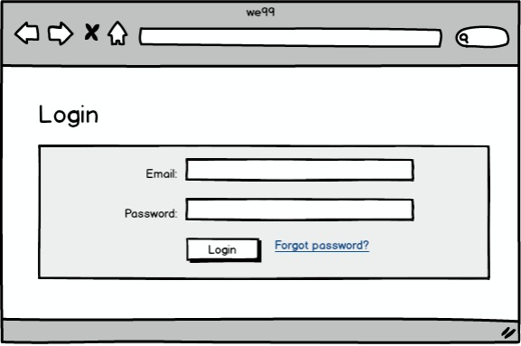

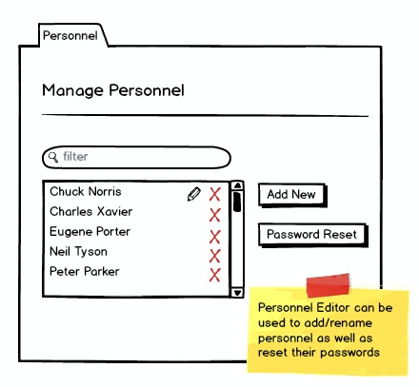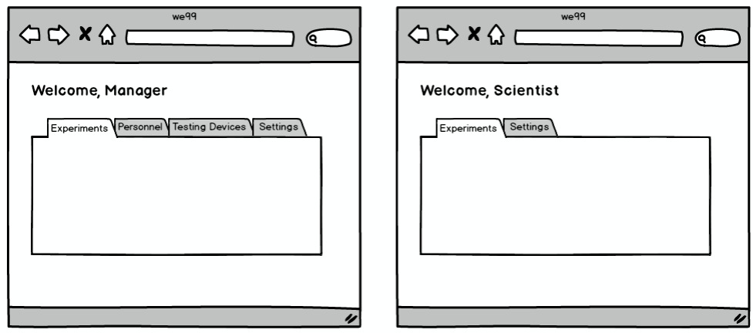

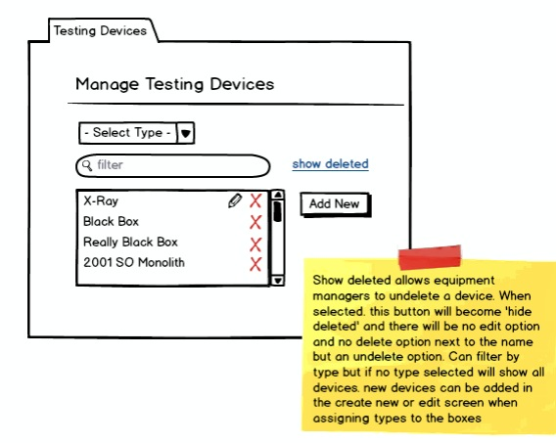

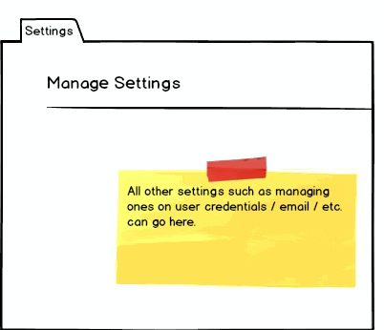

### Open Issues / Questions Security Section

| # | Description | NOtes |
| --- | --- | --- |
| 1 | Can we use Testing devices to manage import export formats of files associated with the device |  |
| 2 | Roles – Are there any other roles besides Manager/Administrator and Scientist that we should add |  |
| 3 | Organization Units – Is there a need to allow organizational groupings to manage accounts in large corporate environments |  |

## 

## Plate Management Requirements

### Plate Management Overview

Plate Management covers creating specification of the contents of microtitre plates to be used in experiments. Users can create plates of any dimension and can specify the compound and the concentration of each compound to be added to each well.

Plate specifications can be cloned, altered and modified for new experiments. Plate specifications can be exported for use sending to robotic labs to fill the plates to be used in the experiment.

Plates are identified with a name and/or barcode. Plates are assumed to be rectangular and can be created in any rectangular dimension. The dimension is specified using the number of rows and the number of columns. The product of rows x columns defines the number of wells that a plate possesses.

Plates are made ready for experiment by filling the wells with compounds (or substances). The wells are filled using the “Assign Wells” screen. Plate specifications (includes details of the plate dimension and the contents and concentration of each well) can be imported or exported to facilitate data transmission to plate filling robotic equipment.

Compounds have a name and a concentration. The concentration of a compound is specified via a number and a unit of measure. Compounds are classified as follows:

* EXP – experimental compound
* POS – positive control
* NEG – negative control

### Sample Screens / Story Board

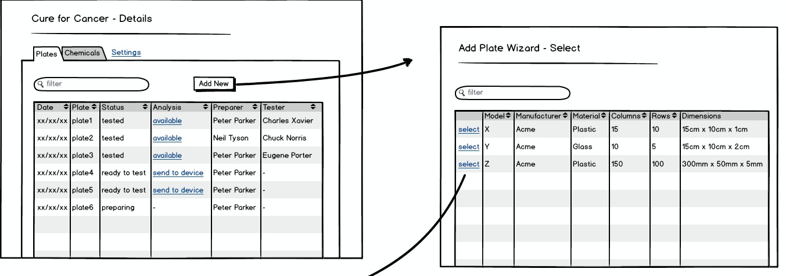

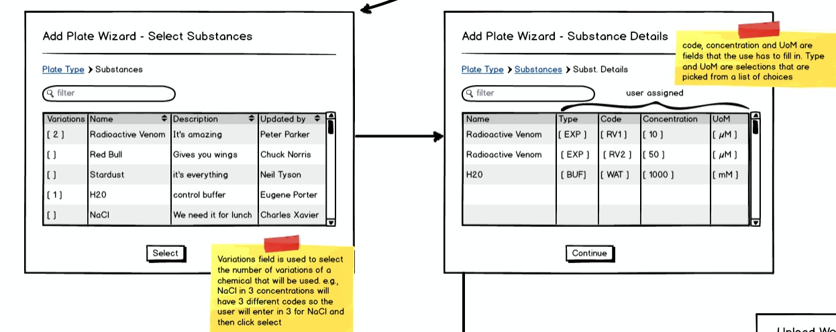

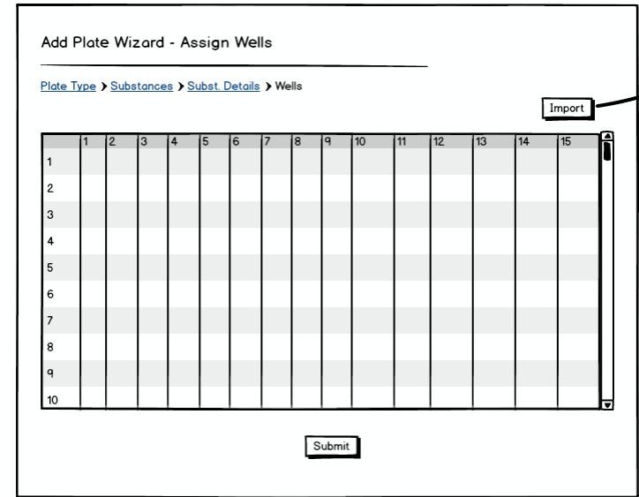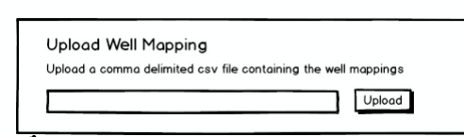

PROPOSAL: Shared plate button.

A shared plate could be produced here.

- click the shared plate button

- Goes to page asking for which experiments to share with

- Goes to the select plate page

- Goes to page asking to select rows and columns. Shows the mapping and allow users to select rows and columns that they want. Ideally the user could highlight a cell and click and drag to get the range they want. However, if we can’t do that then just select the rows and columns with checkboxes, their intersect is what is selected.

- The user is taken to the select substance page and the rest of the wizard is the same as the regular plate creation wizard.

For now, imports and exports of shared plates are not supported.

Shared Plate Edit:

Editing plates is currently not supported.

Shared Plate Deletion:

If the delete button is selected, a shared plate is only removed from the list of available plates and only visibility to the experiment is removed. The plate is only truly deleted when all experiments remove access

### Open Issues / Questions Plate Management

| # | Description | NOtes |
| --- | --- | --- |
| 1 | Is there a need for Plate Templates? Adding placeholders for compounds, controls and empty. Perhaps including an index for dosage. Merge the Compound list with the template to create a plate.  Is cloning the plate a reasonable alternative to the template concept |  |
| 2 | For dose response analysis. Applying doses or concentrations of compounds. Is there a shorthand e.g. 20uM 5-fold? |  |
| 3 | Ability to create plates of any dimension. |  |
| 4 | Exporting plate specs. Is there a standard format? Do we need to handle with different parsers tied to equipment type? |  |

## Experiment Management Requirements

### Overview

Experiments can be created and deleted by an administrative user. An experiment is identified with a unique name. A description of the experiment can also be included. An administrative user can also create teams of scientists for an experiment.

Experiments may use a single of a set of filled plates. The plates used in an experiment can be listed. A team member can add new plates to an experiment.

Plates have a status:

* **Creating**– a plate in this state is in the process of being defined (see plate management)
  + Shared plates that have not been allocated can be started by clicked not started. Note that all shared plates have a common ‘Ready to Test’ and Tested state.
* **Preparing** – a plate in this state is in the process of being filled with product.
* **Ready to test** – a plate in this state is filled and is ready to be tested.
* **Tested** – a plate in this state has been tested and results are pending.

**Plates also have an Analysis status:**

* **Available** – Test results are available. When the available link is pressed the user is directed to the results analysis for that plate.
* **Send to Device** – Plates can be assigned to a specific device for testing. When the send to device link is pressed the user may select the test equipment that the plate is to be send to.
* **In testing** – When a plate is sent to a device for testing its status changes to in testing.
* n/a – the plate can also have no analysis state.

### Sample Screens / Story Board

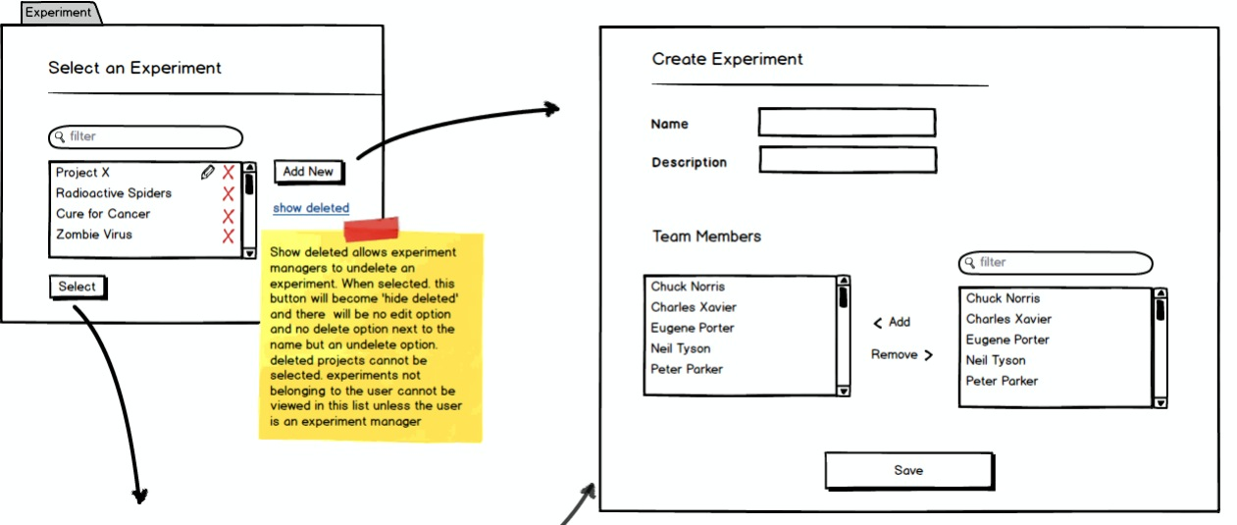

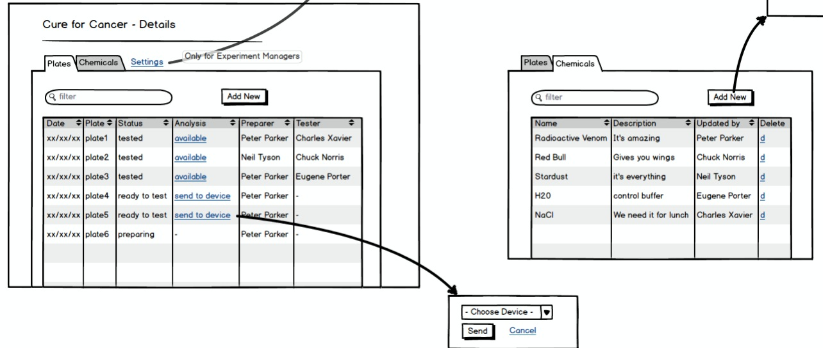

### Open Issues / Questions Experiment Management

| # | Description | NOtes |
| --- | --- | --- |
| 1 | Adding Compounds. Is there a need to do this in a bulk import? |  |
| 2 | Might need Need a separate role and management view for ‘mark as prepared’. | e.g., this is where a lab assistant could mark plates as prepared and the status is updated to the project. |

## Results Analysis Requirements

### Overview

A plate will be analyzed by a machine - which will generate a structured text file as output. The user will upload the structured text file into the web application and select an appropriate parser to convert it into a result set. The results for the uploaded plates will be displayed to the user for validation in the form of a heat map.

While reviewing the results as a heat map the user will be able to read information about,

1. The results values.
2. The concentration of compounds in the wells.
3. The compounds in the wells.
4. What type of well’s are which (ex. EXP, POS, NEG).

### Sample Screens / Story Boards

Step 1 – Select a file and an algorithm to upload.

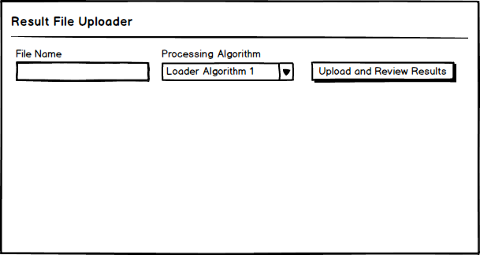

Step 2 – Review the results and save them if they look appropriate.

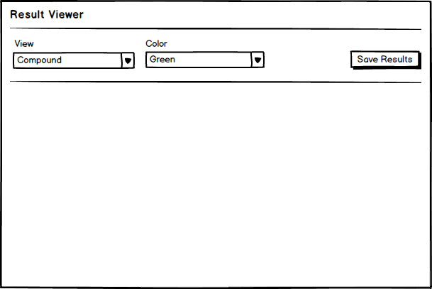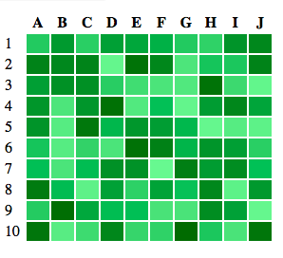

Plate 1

Plate 2

Plate 3

### Open Issues / Questions Results Analysis

| # | Description | NOtes |
| --- | --- | --- |
| 1 | When reviewing the result in the form of a heat map is there any workflow for processing the results beyond saving. For example -- if a plate looks like it has issues should the system allow them to flag the plate as problematic, etc? |  |
| 2 |  |  |
| 3 |  |  |

## Special Feature Proposals

### Overview

We have includes a few special features that we were considering implementing as part of the system.

### Interactive Visualization

Allow the user to remove plot points from an Experiment's results. They will see the raw data from the processing in a scatter plot where we fit a curve to the data. The user can select points in the UI and remove them which will cause the graph to render the curve line again.

We will track which points were removed and enable users to provide comments as to why they were removed.

When removing points, you can offer a preview view. This would generate a new regression on the fly when certain points are selected to be removed. This can either be saved which would create the change and audit trail or the scientist could cancel changes.

#### Sample Screens / Story Boards

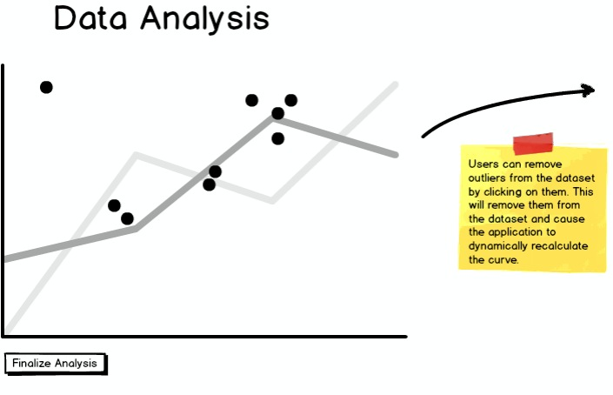

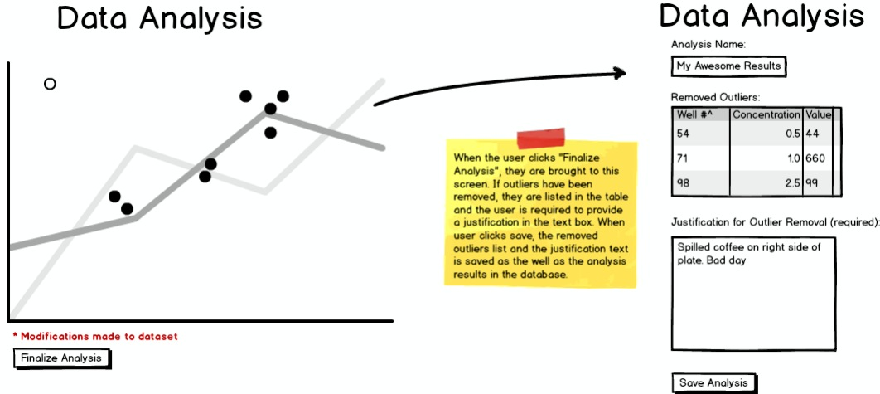

### Audit Trail

We could track whenever a Plate / Well / Dose / Experiment changes. This would allow users to know when something in the system has changed and may be necessary for internal reporting or perhaps regulatory agency requirements.

Assuming that we have some type of relational database, we should hook into the changes at the transaction level so the audit trail is captured in the same atomic operation as the data is changed. Note: there's a good library from Hibernate for this called Envers.

#### Sample Screens / Story Boards

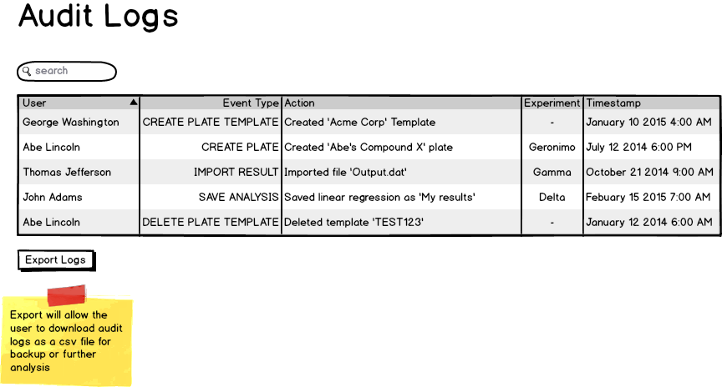

### Four Eyes Protocol

Changes to experiment results or perhaps the plate configuration before an experiment should require a second person to review or approve the change. This would assume that we have an authentication model in place so we know which users own an Experiment and thus which users would be eligible to approve the change,

#### Sample Screens / Story Boards

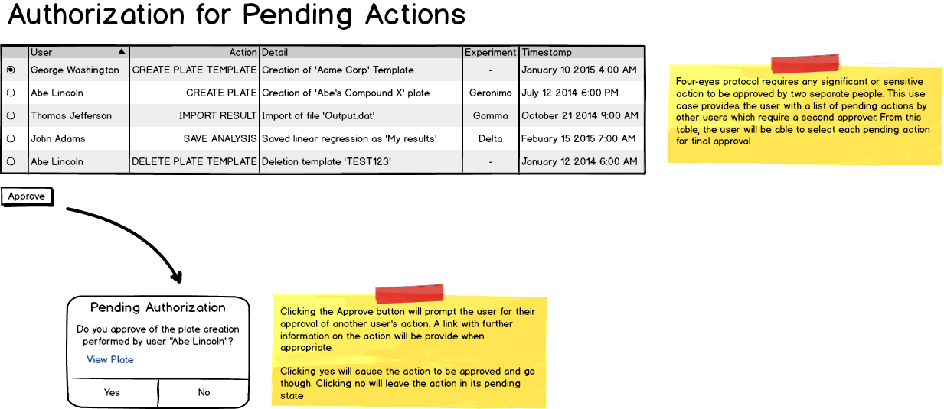

### Flexible Plate Template Editor

Plate templates can be saved and loaded so that they can be shared. The save file is a clear format (e.g., csv) that could be edited directly with a text editor/excel. Alternatively the webapp interface can have a table that lets you design the plate.

### Plate Sharing

In some cases a plate may need to be shared across multiple Experiments. This may be a cost or resource issue. In order to support this, we need to associate wells to an experiment and not assume that a plate belongs to a single Experiment.

### Support Machine / Equipment File parsers

If we are storing data regarding the equipment used for an experiment we could possibly have the ability to customize output file formats for the type of equipment. This could also apply to parsing the results files from different machine types.

### Open Issues / Questions Special Features

| # | Description | NOtes |
| --- | --- | --- |
| 1 | For the data analysis portion of this they are represented as scatter plots. What should the x and the y axis of the scatter plot be? |  |
| 2 | For the data analysis portion how should the result be filtered. Would people want to look at a specific compound across an entire experiment? Only look at a single plate at a time? Review all plates in an experiment? |  |
| 3 |  |  |